DAIRY FLAT SCHOOL AGRICULTURAL DAY 2020
CAGED PETS
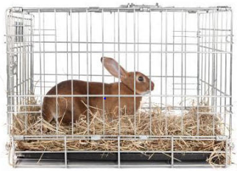
DOGS, cats, horses and donkeys are not permitted on Ag Day. If unsure please check with Mrs Mowat or Mrs Cotter.
For this category you must bring a pet that is at least 1 month old and is used to living in a cage.
Pets can only be entered once in their lifetime (ie. can only come once to Ag Day).
Along with each child entering this category they are required to present a written learning journey of the cage pet’s growth, development and care.
Be creative.
Can be presented in any format eg: diary, A3 poster, fact sheet, digital presentation etc

On Ag Day, animal brought to school in a wired shut cage or a clear secured container - and placed in the allocated area.
Attach your Ag Day number to the cage so it is clearly visible for judging.
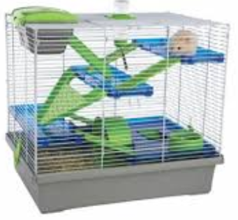
The child must be present, standing alongside their caged pet during judging as the judge will ask the child questions about their caged pet and their learning journey
No parents/caregivers are allowed into the judging area during judging.
Children must be significantly involved in the nurturing and raising of the animal.
Judging Criteria
1. Cage pets must be at least 1 month old
2. Pets can only be entered once in their lifetime (ie. can only come once to Ag Day).
3. All pets must be well controlled on the day.
4. Learning journey must be displayed with your caged pet.
5. Children will be required to verbally share their ‘learning journey’
6. Judges will be looking for creative design work with particular emphasis on how much information and effort (age appropriate) has been put into the learning journey by the child.
7. Learning journeys must include pictures, photos and/or drawings. Ideas could include information about size, weight, housing, food etc
8. Judges will be looking at the general condition and health of the caged pet along with understanding the child’s knowledge of their pet.
THE JUDGES DECISION IS FINAL
Note- Caged pets are not eligible to enter young farmers.

