DAIRY FLAT SCHOOL AGRICULTURAL DAY 2020
Mystery Seed Plant
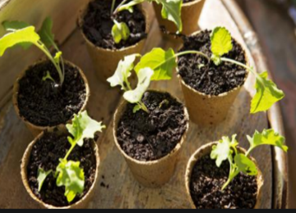
Instructions-
- You will be given a mystery seed and a small jiffy growing pot. (note you’ll need your own potting mix)
You will need to come and pick them up from Room 1 before or after school in Term 3.
Cost-$2 -every time you come and collect more seeds
- First plant in given jiffy pot
- Decorate a larger pot to compliment growing plant eg- if a sunflower-yellow pot covered in suns, bean plant- trellis with Jack climbing up etc
- Replant into your own larger decorated recycled or upcycled container.
Bring to school on Ag day morning- Saturday 17th October, ready for judging.

JUDGING CRITERIA
- Must be grown from school provided seed
- Growing container needs be decorated to compliment your growing plant eg- if a sunflower, pot could be covered in suns and must be made from a recycled or upcycled item
- Judging will be based on health of plant, imagination used to decorate pot and use of recycled or upcycled pot.

Handy hint- find out what you plant is- App- Indigo Plant Recognition
The Mystery Seed Plant is to be brought to school and placed in the allocated area before 9am on Ag Day for judging.
You will need to display your Ag Day number on your exhibit (these numbers will be given to you prior to Ag Day).

