DAIRY FLAT SCHOOL AGRICULTURAL DAY 2020
FAMILY SCARECROW
For this category you will need to make a traditional scarecrow from upcycled or recycled materials
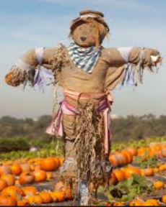
This year you will be making a scarecrow as a family.
Parts of the scarecrow can be made at home, but must be constructed at school on Saturday.
A wooden cross is available at school on Saturday for $4. Need to be paid for prior to Ag day.
You must provide all other materials to construct your scarecrow including stuffing.
Needs to be made from recycled and/or upcycled material.

Judging Criteria:
1. Scarecrow needs to look like a scarecrow that belongs in the garden.
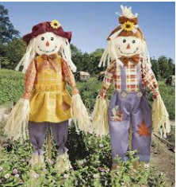
2. Parts may be made at home and then constructed into scarecrow at school.
3. Looking for attention to detail.
4. Creativity in use of recycled materials or upcycled materials.
5. Can use a range of materials, textures, fabrics, paint, ribbon, wool,
rope, pipes, metal, cans etc
6. Scarecrows are to be made at school on the morning of Ag Day.
7. As this is a family scarecrow you will need to display your child/children’s Ag Day number/ numbers on your exhibit.

Remember to take your scarecrow home at the end of Ag Day along with any leftover bits and pieces.
A wooden cross can be provided at a cost of $4.
Please put money in a named envelope in the box labelled ‘Scarecrow’ in the office or pay by internet banking straight into the PTA bank account.
Account number – 12-3046-0270392-00. Please put your child’s name as the reference.

